مقطع تحصیلی:کاردانی■کارشناسی رشته: مترجمی آثار مکتوب و متون رسمی ترم: دوم سال تحصیلی: 1398- 1399
نام درس:.ترجمه رسمی متون اداری و بازرگانی نام ونام خانوادگی مدرس: عارفه امینی فسخودی
آدرس email مدرس: Arefe.amini@gmail.com تلفن همراه مدرس:09126366912
جزوه درس: ترجمه رسمی متون اداری و بازرگانی . مربوط به هفته : اول■ دوم سوم
text: دارد ■ندارد voice:دارد ندارد ■ power point:دارد ندارد■
تلفن همراه مدیر گروه : ............................................

Dear all,
the followings are the important issues which should be borne in mind during the whole term:

- Course book: Ashley, A. (2005). Oxford Handbook of Commercial Correspondence. Oxford University Press.

- You can either use the printed book or the PDF. The PDF of the book has been shared with you.

- Procedure: During the first 15-20 minutes of each session, you are given feedback on your previously submitted assignments and your questions and difficulties are dealt with. Then, the new lesion is presented to you. Next, a short relevant text is translated collaboratively and cooperatively in the class. In the end, you are assigned a text to work on at home.

- Assignments: They are expected to be assigned before the beginning of the following session. Otherwise, they will not be accepted.

- The importance of class participation: Your active participation is of high importance. Please do not underestimate it.

- Assessment: Not only will your performance on the final exam be assessed, your active participation as well as carefully completed and timely submitted assignments will also be considered.

- The attached pictures provide you with more information on the course, content, assessment, and regulations. Please read them carefully. You are also provided with some information on the course’s instructors.

- Please feel free to contact me on WhatsApp whenever you have any questions.

- Wish you all health, happiness, and prosperity.

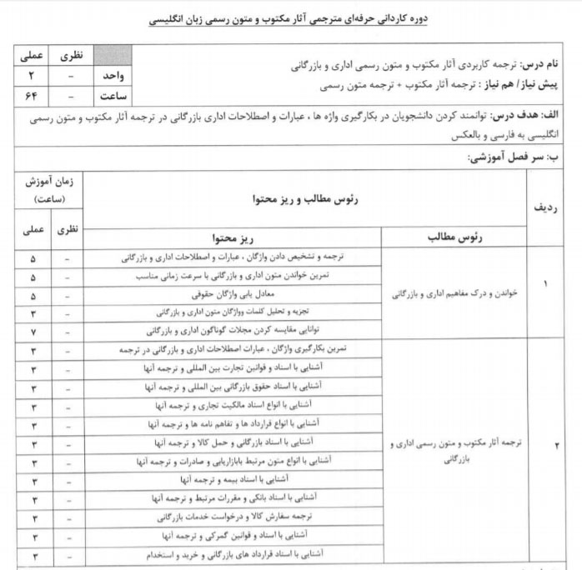

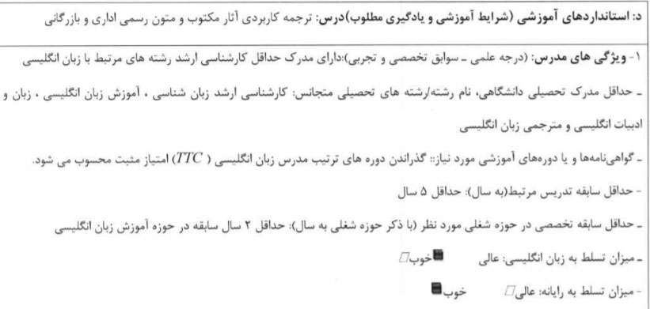

Good luck

