مقطع تحصیلی:کاردانی■کارشناسی رشته: مترجمی آثار مکتوب و متون رسمی ترم: دوم سال تحصیلی: 1398- 1399
نام درس:.آزمایشگاه مقدماتی نام ونام خانوادگی مدرس: عارفه امینی فسخودی
آدرس email مدرس: Arefe.amini@gmail.com تلفن همراه مدرس:09126366912
جزوه درس: آزمایشگاه مقدماتی درس 11 . مربوط به هفته : اول دوم ■سوم
text: دارد ■ندارد voice:دارد ندارد ■ power point:دارد ندارد■
تلفن همراه مدیر گروه : ............................................

Look at the following words.

item | pronunciation | definition
invitation n | /ˌɪnvɪˈteɪʃn/ | a spoken or written request to somebody to do something or to go somewhere
accept v | /əkˈsept/ | to take willingly something that is offered; to say ‘yes’ to an offer, invitation, etc.
refuse v | /rɪˈfjuːz/ | to say or show that you will not do something that somebody has asked you to do
decline v | /dɪˈklaɪn/ | to refuse politely to accept or to do something

For more information, you can follow the link https://www.oxfordlearnersdictionaries.com/.

Here are some expressions used in order to make invitations:

- Do you feel like going for a walk?
- Do you want to go to the movies tonight?
- Would you like to play cards?
- Would you like a cup of coffee?
- What about a cup of tea?
- I would like you to have lunch with us tomorrow.
- Would you be interested in going to the movies tonight?
- Why don’t you have lunch with me tomorrow?
- How about joining me for a walk?
- I invite you to have breakfast with me tomorrow morning.

Some ways for accepting an Invitation:

- Thank you for your kind invitation.
- I’d love to, thanks.
- I’ll be glad to do so.
- Thanks, I’d like that very much.
- That’s a great idea.
- Thanks for inviting me to dinner.
- It’s very nice of you.
- Many thanks for your kind invitation. I’ll join you.
- Sure. Thank you.
- With pleasure!

Refusing an Invitation:

- I’m sorry to refuse your invitation.
- I can’t, sorry. I have to work.
- Thanks for your invitation but I’m busy now.
- I’m afraid I won’t be able to come.
- I’m afraid I am busy tomorrow.
- Sorry, I’d love to but I have an appointment.
- I really don’t think I can, sorry.
- That’s very kind of you, but I can’t accept your invitation.

Here are some tips on how to politely decline an invitation:

- Don't ignore the invitation. The person needs to know whether or not you will be there. Ignoring the invitation shows that you do not know proper etiquette and you might be left off the guest list for her next party.

- As soon as you know you will be unable to go, let the person know. Most events require planning and budgeting.

- Be thankful. Always sincerely thank the person for inviting you and let her know that you are honored that she'd think highly enough of you to send the invitation.

- Be honest. You do not ever have to come up with false excuses for why you're unable to go to the event, but you also do not have to go into detail. Let her know that you already have plans. That should be enough.

- Ask for a different time. If the invitation is exclusive to you, let the person know you are unable to make it at the time she requested, but you'd love to get together with her at another time. This is obviously not an option if it's a group get-together.

- Don't over-explain. If you can't make it, keep your explanation short and to the point. Doing otherwise will make it sound like you're just trying to come up with excuses.

- Send something. If you would typically bring a gift to whatever event you were invited to, such as a birthday party or baby shower, go ahead and send something with a card attached. Mention something about wishing you could be there and add that you look forward to seeing her soon.

Now look at the following responses and decide if they are used to accept or decline an invitation:

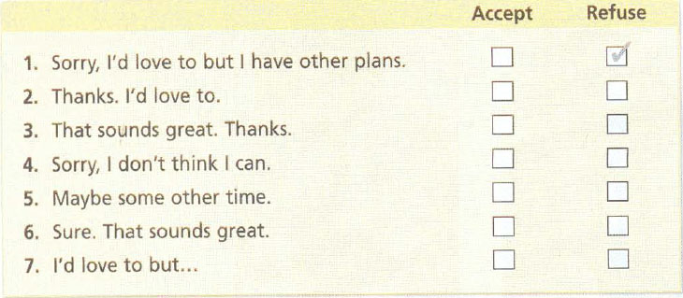

Now, please listen to the tracks and do the exercises on the relevant pages. The answers will be checked on WhatsApp.

Please do not hesitate to contact me directly on WhatsApp should you have any problems.

Wish you all health, happiness, and prosperity.

