مقطع تحصیلی:کاردانی■کارشناسی رشته: مترجمی آثار مکتوب و متون رسمی ترم: دوم سال تحصیلی: 1398- 1399
نام درس:.مکالمه موضوعی نام ونام خانوادگی مدرس: عارفه امینی فسخودی
آدرس email مدرس: Arefe.amini@gmail.com تلفن همراه مدرس:09126366912
جزوه درس: مکالمه موضوعی . مربوط به هفته : اول دوم ■سوم
text: دارد ■ندارد video:دارد■ ندارد power point:دارد ندارد■
تلفن همراه مدیر گروه : ............................................

Speak Now 2 (Units 2 & 3)

- Please perform the following steps:

- Here is the list of vocabulary, all adjectives, which might be new to some of you. You might need to follow the link https://www.oxfordlearnersdictionaries.com/ in order to check the pronunciation and find more information on the given words:

item | pronunciation | definition | example
elderly | /ˈeldərli/ | (of people) used as a polite word for ‘old’ | elderly patients/residents
middle aged | /ˌmɪdl ˈeɪdʒd/ | ​(of a person) neither young nor old | His sisters are grown up and his parents are middle-aged.
pretty | /ˈprɪti/ | (especially of a woman, or a girl) attractive without being very beautiful | a pretty face
good looking | /ˌɡʊd ˈlʊkɪŋ/ | (especially of people) physically attractive | a good-looking man/couple
confident | /ˈkɑːnfɪdənt/ | feeling sure about your own ability to do things and be successful | I was actually fairly confident about my chances.
creative | /kriˈeɪtɪv/ | involving the use of skill and the imagination to produce something new or a work of art | the company’s creative team/director
forgetful | /fərˈɡetfl/ | ​often forgetting things | She has become very forgetful in recent years.
impatient | /ɪmˈpeɪʃnt/ | annoyed by somebody/something, especially because you have to wait for a long time | The children were growing impatient.
outgoing | /ˌaʊtˈɡəʊɪŋ/ | liking to meet other people, enjoying their company and being friendly towards them | I’ve become more confident and outgoing.

- Watch the video, shared with you, and then look at the following boxes:
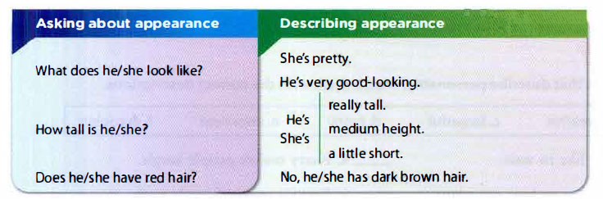

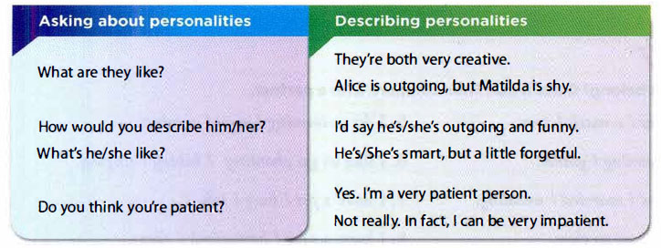

- Now, please look at the pages 4, 5, 6, & 7 of your books and if you have any problem, let me know about it.

- Choose one of your favorite actors, singers, or sportsperson. Now, keeping in mind the following points, talk about the person for about two minutes and record your voice. Then share your recorded voice in the group:

- First, introduce him/her.
- Talk about his/her appearance.
- Let us know a bit about his/her personality.
- Do you know anything about his/her hobbies?

- Each of you is expected to give feedback to at least one of the classmates on his/ her recorded voice. Remember to choose one of your friends who has not received feedback yet; so that, in the end each of you is provided with feedback.

- Please feel free to contact me should you have any questions.

Good luck

