مقطع تحصیلی:کاردانی■کارشناسی رشته: مترجمی آثار مکتوب و متون رسمی ترم: دوم سال تحصیلی: 1398- 1399
نام درس:.خواندن و درک آثار مکتوب نام ونام خانوادگی مدرس: عارفه امینی فسخودی
آدرس email مدرس: Arefe.amini@gmail.com تلفن همراه مدرس:09126366912
جزوه درس: خواندن و درک آثار مکتوب . مربوط به هفته : اول دوم سوم■
text: دارد ■ندارد voice:دارد ندارد ■ power point:دارد ندارد■
تلفن همراه مدیر گروه : ............................................

- Here is the list of the vocabulary you may face while reading the text. Having checked these words, please complete the table. The answers will be checked in the class.

item | definition
convention
inherent
dignity
fundamental
impairment
hinder
barriers
tactile
recognition
disproportionate
administrative
restriction
burden
inclusion
assistive
preserve
identity
accommodation
alternative
mode
impair
nullify
impose
accessible
undue

- The text presents two articles of the “Convention on the rights of persons with disabilities”. Please have a very short look at the text to see what it talks about.

- Before moving to the next exercise, if you have any problems understanding the text, please feel free to contact me on WhatsApp.

- Having read the text, answer the relevant questions.

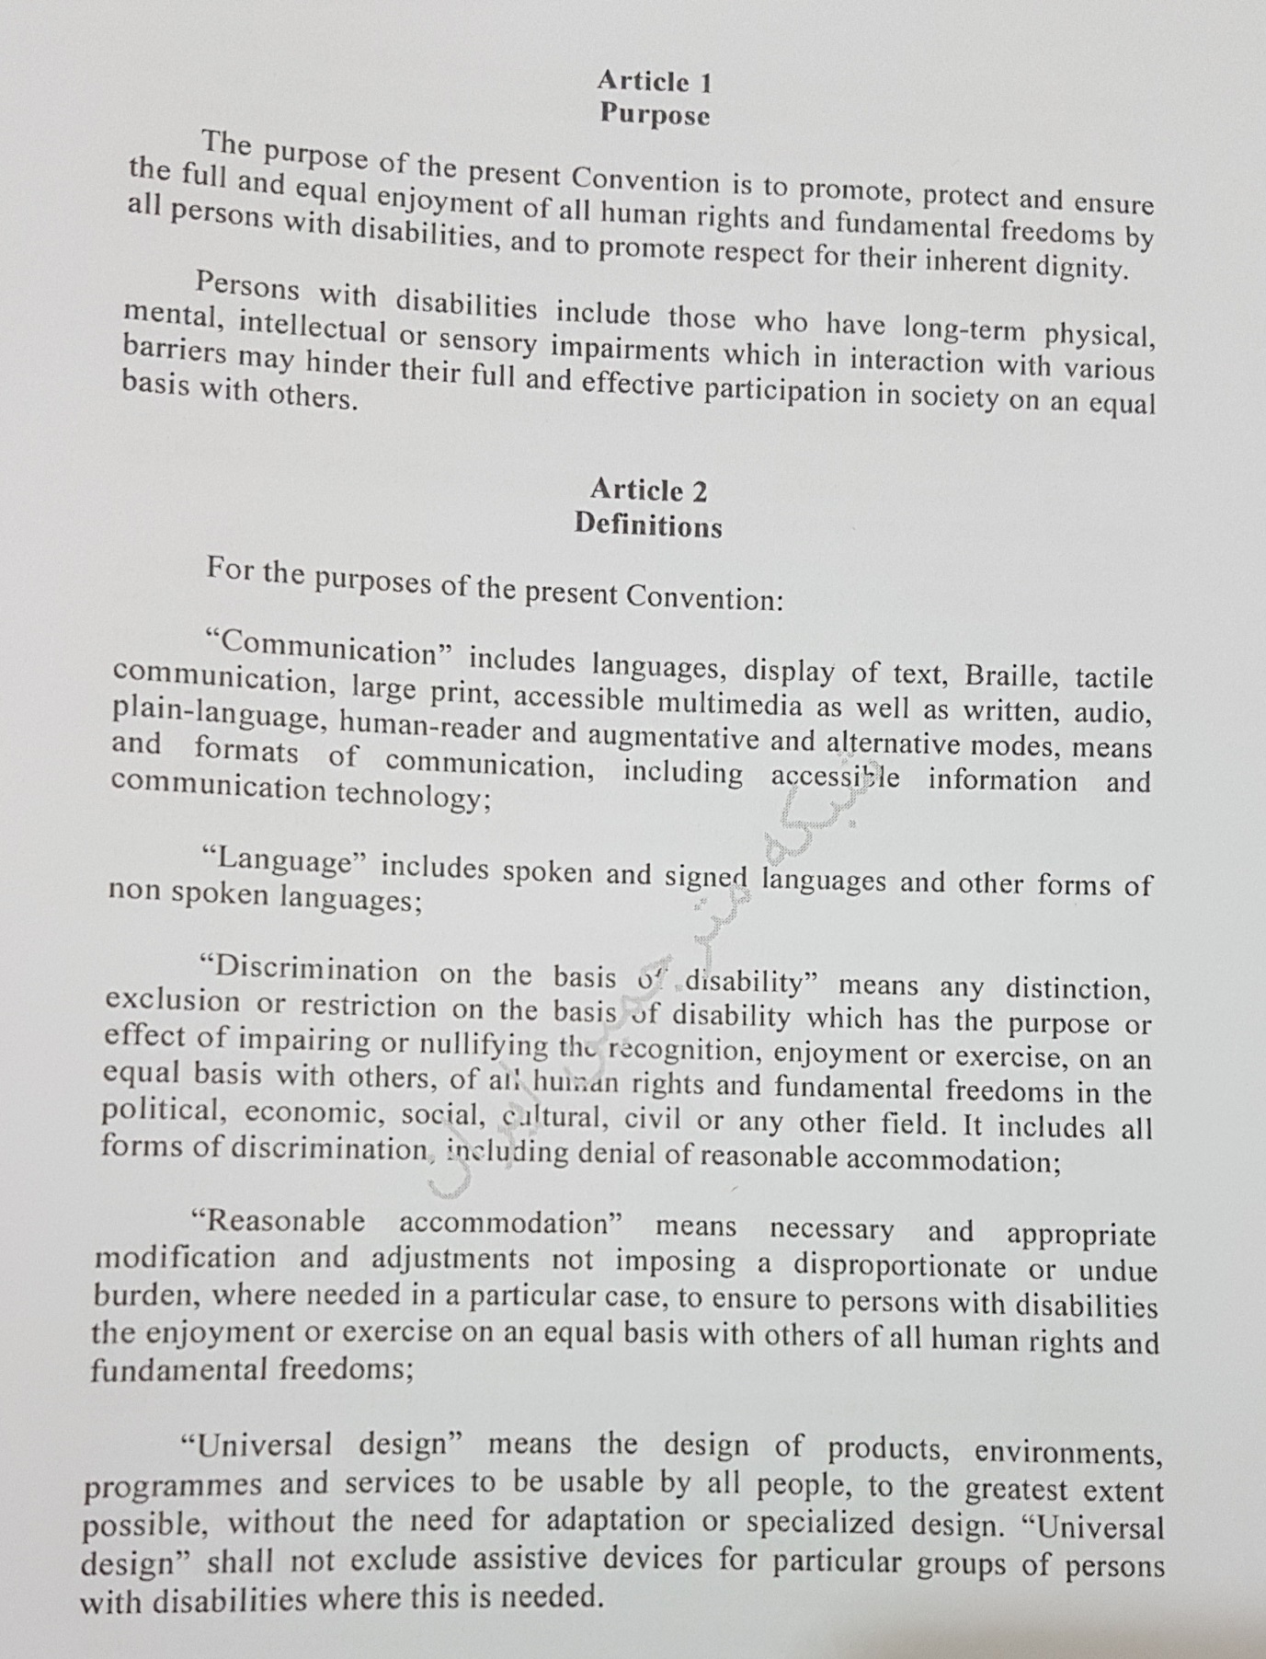

- What does the convention aim to do?
- Who are considered as “persons with disabilities, according to this convention?
- How are “communication” and “language” related to one another?
- What does “reasonable accommodation” refer to?
- What does “universal design” mean?

- Please try to collect more information on this convention and share it with us on WhatsApp.

- Please do not hesitate to contact me directly on WhatsApp should you have any problems.

- Wish you all health, happiness, and prosperity.

