مقطع تحصیلی:کاردانی■کارشناسی رشته: مترجمی آثار مکتوب و متون رسمی ترم: دوم سال تحصیلی: 1398- 1399
نام درس:.آزمایشگاه مقدماتی نام ونام خانوادگی مدرس: عارفه امینی فسخودی
آدرس email مدرس: Arefe.amini@gmail.com تلفن همراه مدرس:09126366912
جزوه درس: آزمایشگاه مقدماتی درس 10 . مربوط به هفته : اول دوم سوم چهارم ■ پنجم
text: دارد ■ندارد voice:دارد■ ندارد (داخل گروه) power point:دارد ندارد■
تلفن همراه مدیر گروه : ............................................

Fit /fɪt/: healthy and strong, especially because you do regular physical exercise

- She tries to keep fit by jogging every day.
- He is back in training after his back injury but is not yet considered match fit (= fit enough to play in a match).
- Hiking helps keep him physically fit.
- fit to do something: He won't be fit to play in the match on Saturday.
- fit for something (British English): He's had a bad cold and isn't fit enough for work yet.

Look at the following words which you will be faced with during the unit.

item | pronunciation | definition
diet (n) | /ˈdaɪət/ | the food and drink that you eat and drink regularly
tighten (v) | /ˈtaɪtn/ | to hold or fix something more securely in position; to make something or become more difficult to move, open or separate
sit-up (n) | /ˈsɪt ʌp/ | an exercise for making your stomach muscles strong, in which you lie on your back on the floor and raise the top part of your body to a sitting position
jogging (n) | /ˈdʒɑːɡɪŋ/ | ​the activity of running slowly and steadily as a form of exercise to go jogging
put on phrasal verb |  | ​to become heavier, especially by the amount mentioned SYNONYM gain
join (something) (v) | /dʒɔɪn/ | to become a member of an organization, a company, a club, etc.

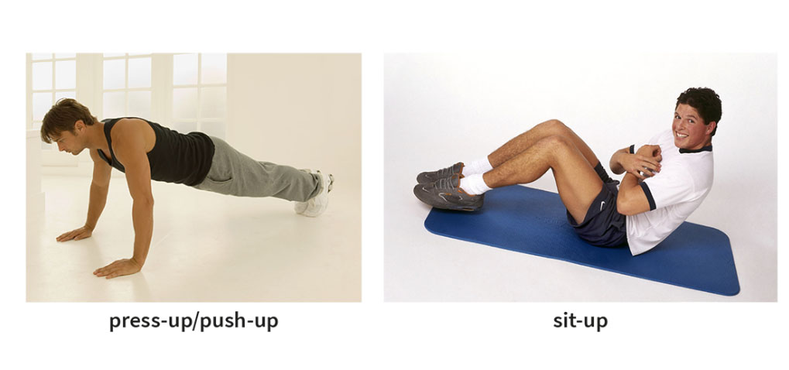
For more information, you can follow the link https://www.oxfordlearnersdictionaries.com/.

Now, please listen to the tracks and do the exercises. The answers will be checked on WhatsApp.

Please do not hesitate to contact me directly on WhatsApp should you have any problems.

Wish you all health, happiness, and prosperity.
