مقطع تحصیلی:کاردانی■کارشناسی رشته: مترجمی آثار مکتوب و متون رسمی ترم: دوم سال تحصیلی: 1398- 1399
نام درس:.خواندن و درک آثار مکتوب نام ونام خانوادگی مدرس: عارفه امینی فسخودی
آدرس email مدرس: Arefe.amini@gmail.com تلفن همراه مدرس:09126366912
جزوه درس: خواندن و درک آثار مکتوب . مربوط به هفته : اول دوم سوم چهارم■ پنجم
text: دارد ■ندارد voice:دارد ندارد ■ power point:دارد ندارد■
تلفن همراه مدیر گروه : ............................................

- Have you ever been to book fairs? What do you know about the Tehran International Book Fair?

- Can you name some domestic and International publishers?

- Now read the text below on page 10 of your book:

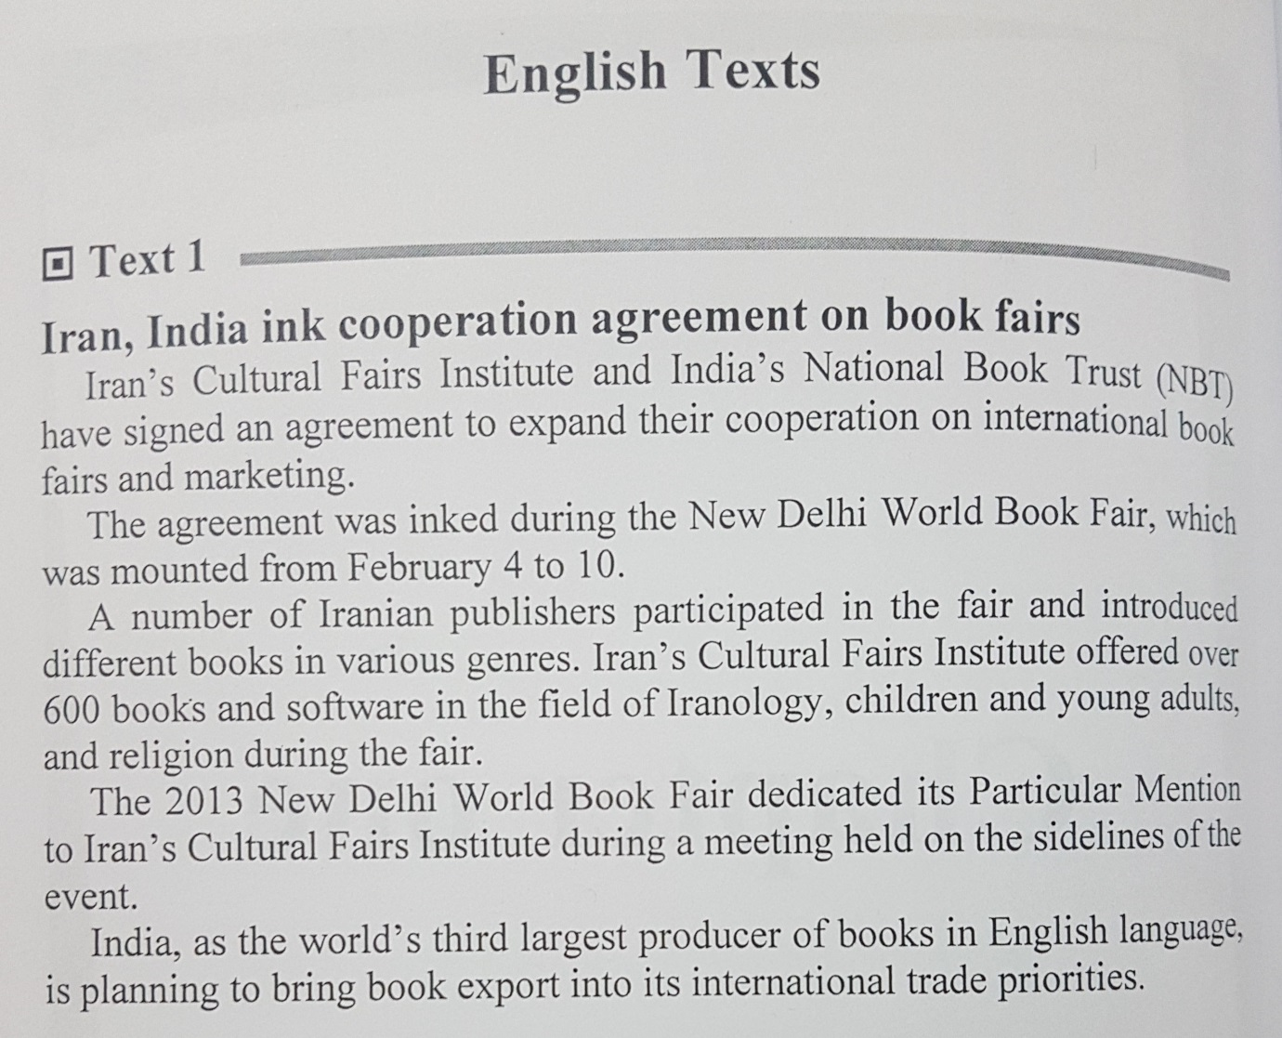

- Now translate the text into Persian.

- Before moving to the next exercise, if you have any problems understanding the text, please feel free to contact me on WhatsApp.

- Write a clear definition as well as a Persian equivalent in front of each item:

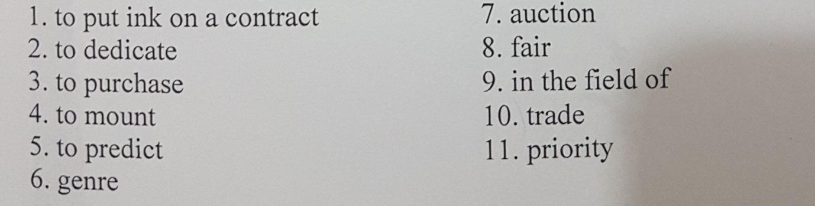

- Now fill in the gaps with the correct form of the above vocabularies.

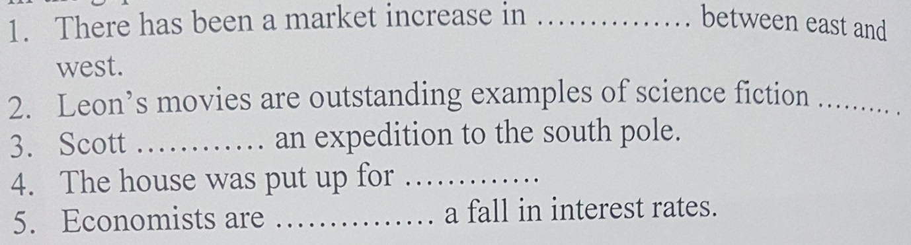

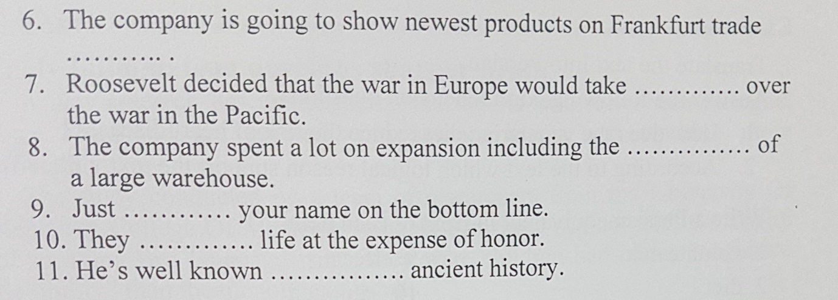

- Now answer the following questions and send me your answers on WhatsApp:

- What are the benefits of such cooperation agreements on book fairs?
- Can you think of some reasons why these two countries decided to ink this cooperation agreement?
- Do you know any Indian authors or publishers?

- Please do not hesitate to contact me directly on WhatsApp should you have any problems.

- Wish you all health, happiness, and prosperity.

