مقطع تحصیلی:کاردانی■کارشناسی رشته: مترجمی آثار مکتوب و متون رسمی ترم: دوم سال تحصیلی: 1398- 1399
نام درس:.آزمایشگاه مقدماتی نام ونام خانوادگی مدرس: عارفه امینی فسخودی
آدرس email مدرس: Arefe.amini@gmail.com تلفن همراه مدرس:09126366912
جزوه درس: آزمایشگاه مقدماتی درس 13 . مربوط به هفته : اول دوم سوم چهارم پنجم ■
text: دارد ■ندارد voice:دارد■ ندارد (داخل گروه) power point:دارد ندارد■
تلفن همراه مدیر گروه : ............................................

hobby /ˈhɑːbi/: an activity that you do for pleasure when you are not working

- My favorite hobby is definitely scuba diving.
- Her hobbies include swimming and gardening.
- Why don't you take up a new hobby?

pastime /ˈpæstaɪm/: ​something that you enjoy doing when you are not working SYNONYM hobby

- Watching television is still the most popular national pastime.
- Fishing is an enjoyable pastime for people of all ages.

Look at the following words which you will be faced with during the unit.

item | pronunciation | definition
hiking (n) | /ˈhaɪkɪŋ/ | the activity of going for long walks in the country for pleasure
Comic (adj) | /ˈkɑːmɪk/ | humorous and making you laugh
band (n) | /bænd/ | a small group of musicians who play popular music together, often with a singer or singers
collection (n) | /kəˈlekʃn/ | ​a group of objects, often of the same sort, that have been collected

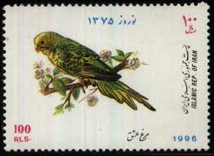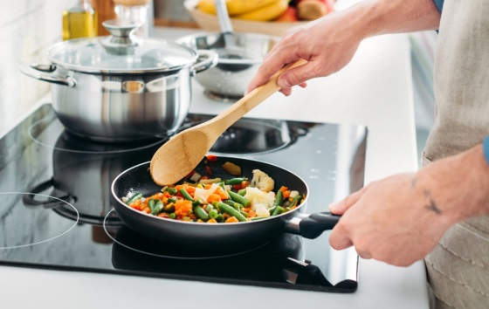
stamp cooking

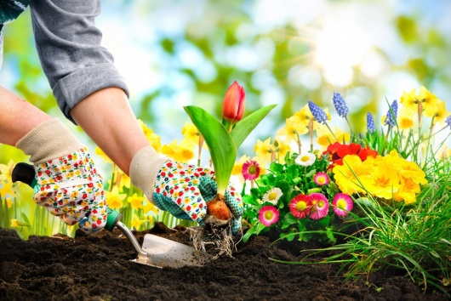
Gardening hiking

For more information, you can follow the link https://www.oxfordlearnersdictionaries.com/.

Now, please listen to the tracks and do the exercises. The answers will be checked on WhatsApp.

Please do not hesitate to contact me directly on WhatsApp should you have any problems.

Wish you all health, happiness, and prosperity.

