مقطع تحصیلی:کاردانی■کارشناسی رشته: مترجمی آثار مکتوب و متون رسمی ترم: دوم سال تحصیلی: 1398- 1399
نام درس:.مکالمه موضوعی نام ونام خانوادگی مدرس: عارفه امینی فسخودی
آدرس email مدرس: Arefe.amini@gmail.com تلفن همراه مدرس:09126366912
جزوه درس: مکالمه موضوعی . مربوط به هفته : اول دوم سوم چهارم پنجم■
text: دارد ■ندارد voice:دارد■ ندارد (داخل گروه) power point:دارد ندارد■
تلفن همراه مدیر گروه : ............................................

Speak Now 2 (Units 12)

- Please perform the following steps:

- Here is the list of vocabulary, which might be new to some of you. You might need to follow the link https://www.oxfordlearnersdictionaries.com/ in order to check the pronunciation and find more information on the given words:

item | pronunciation | definition | example
comfortable adj | /ˈkʌmfərtəbl/ | making you feel physically relaxed; pleasant to wear, sit on, etc. | These new shoes are not very comfortable.
frightening adj | /ˈfraɪtnɪŋ/ | making you feel afraid | a truly frightening horror movie

- Now, look at the following boxes:

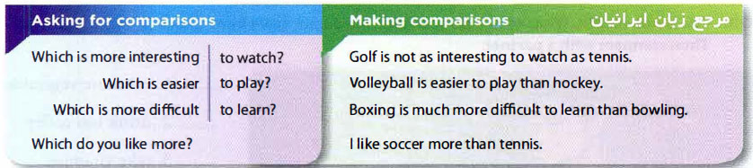

- Review: Look at the pictures from the book English Grammar in Use and listen to my recorded voice on WhatsApp.

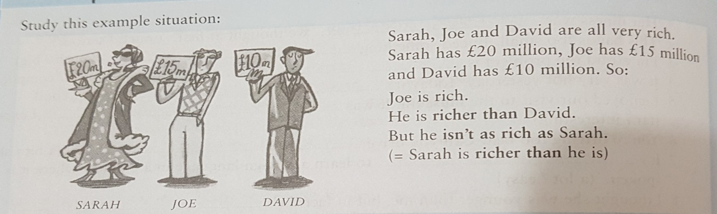

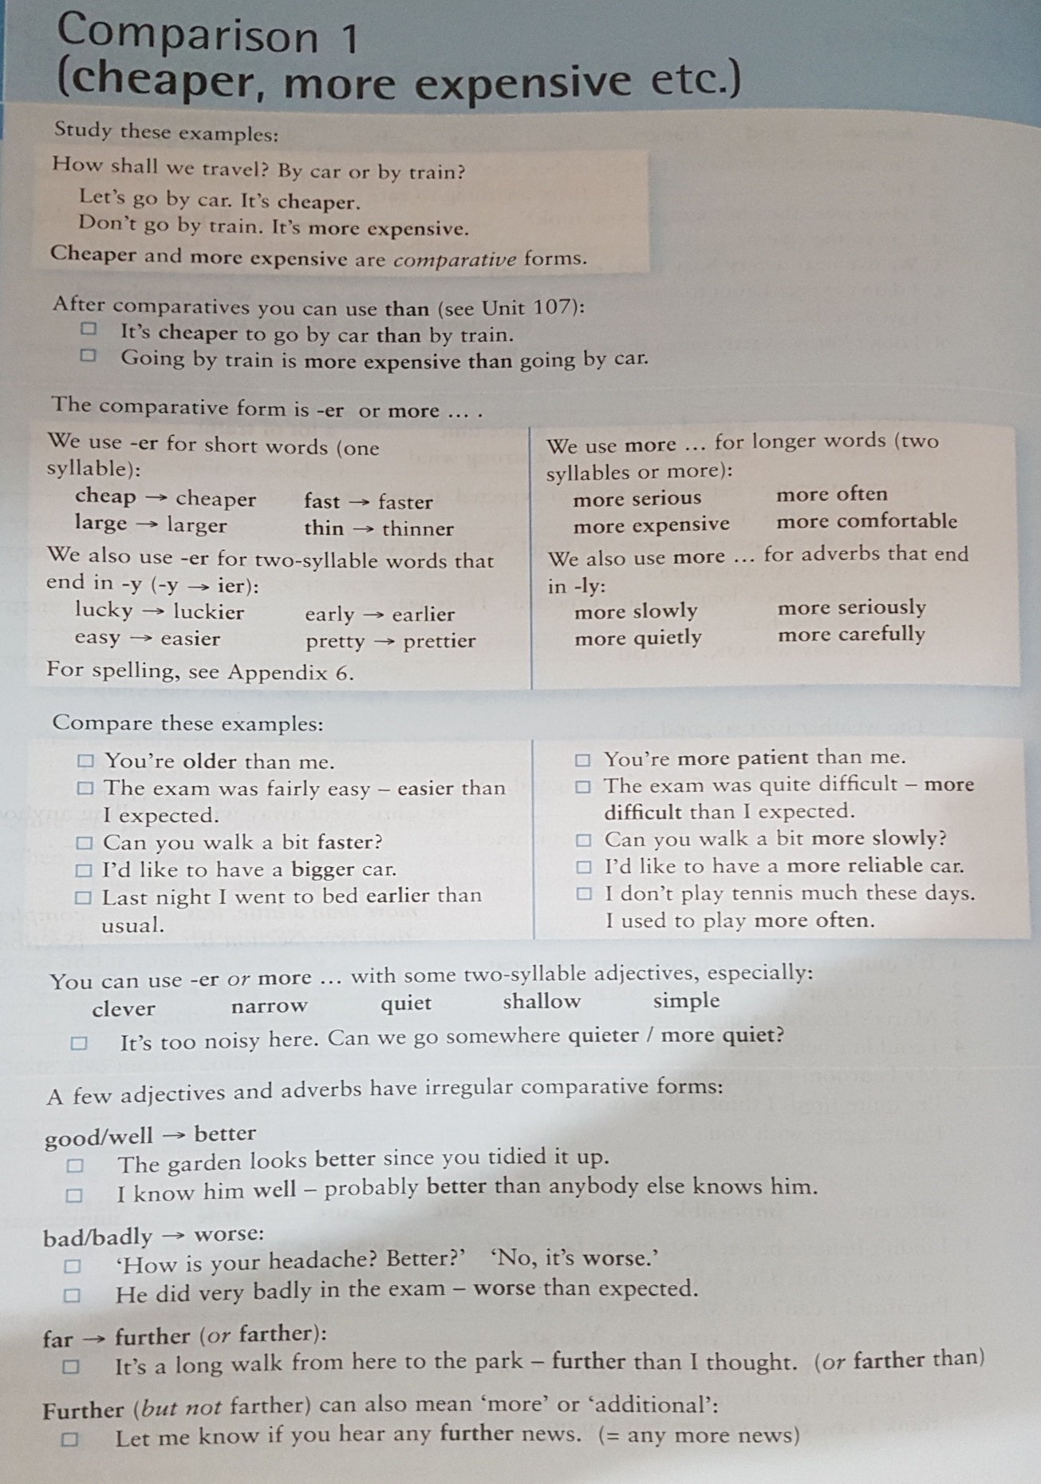

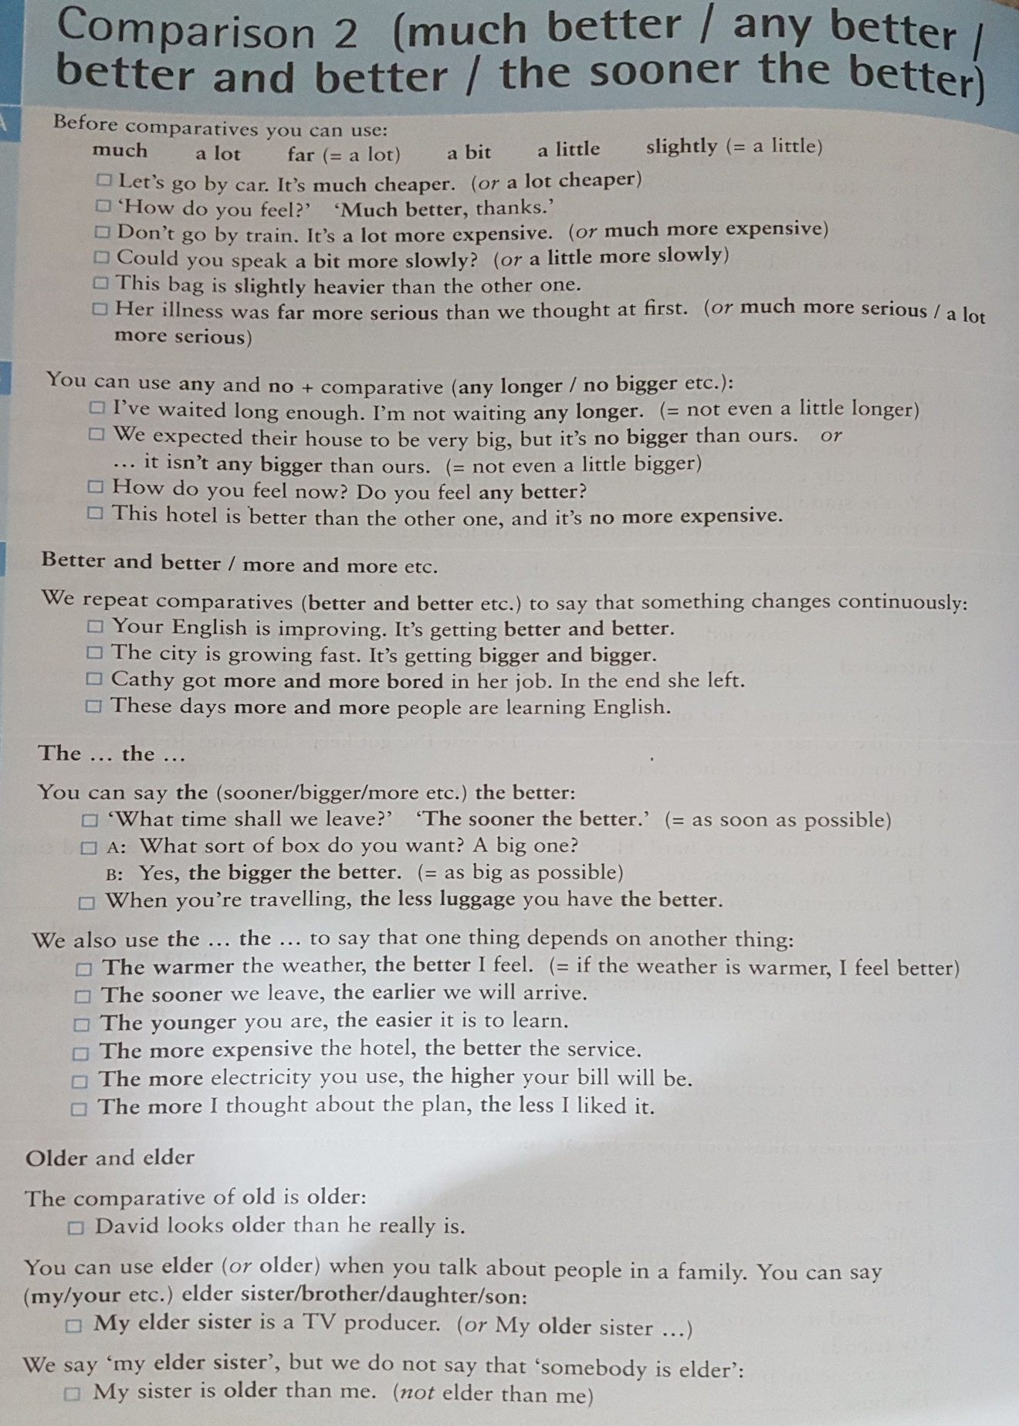

- Now, please look at the pages 28 and 29 of your books and if you have any problems, let me know.

- Choose your favorite sport and then talk about it. Try to compare it with another sport which you like less. You are expected to use as many relevant adjectives as you can. Then, share your voice on WhatsApp.

- Each of you is expected to give feedback to at least one of the classmates on his/ her recorded voice. Remember to choose one of your friends who has not received feedback yet; so that, in the end each of you is provided with feedback.

- Please feel free to contact me should you have any questions.

Good luck

